Class Design - View

# Create Initial Design Classes

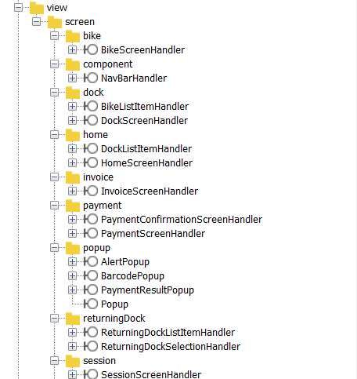

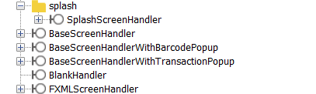

# Define Relationships Between Classes

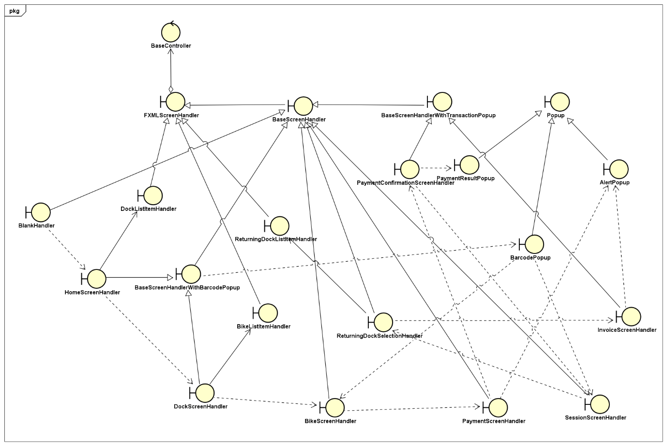

# Class Design

## Class “BikeScreenHandler”

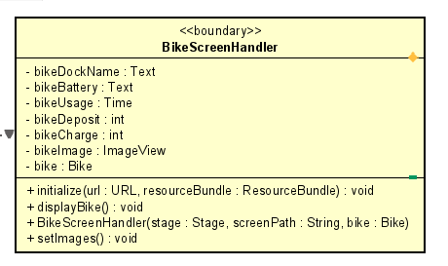

**Attribute**

|  |  |  |  |  |
| --- | --- | --- | --- | --- |
| # | Name | Data type | Default value | Description |
| 1 | bikeDockName | Text | NULL | Dock name fxml |
| 2 | bikeBattery | int | NULL | Bike battery fxml |
| 3 | bikeUsage | Time | NULL | Bike usage fxml |
| 4 | bikeDeposit | int | NULL | Bike deposit fxml |
| 5 | bikeCharge | int | NULL | Bike charge fxml |
| 6 | bikeImage | ImageView | NULL | Bike image |
| 7 | bike | Bike | NULL | bike |

**Operation**

|  |  |  |  |
| --- | --- | --- | --- |
| # | Name | Return type | Description |
| 1 | initialize | void | initialize |
| 2 | displayBike | void | Display bike info screen |
| 3 | setImages | void | Set bike image |

**Parameter:**

* initialize
  + url - URL
  + resourceBundle - ResourceBundle
* BikeScreenHandle
  + stage - Stage

**Exception:**

None

**Method**

None

**State**

None

## Class “DockScreenHandler”

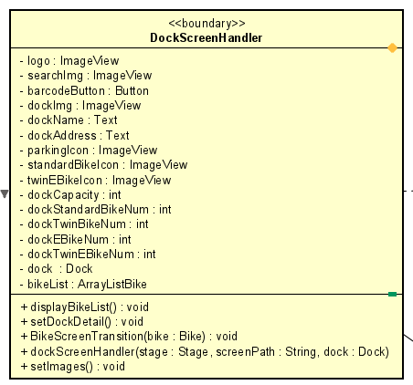

**Attribute**

|  |  |  |  |  |
| --- | --- | --- | --- | --- |
| # | Name | Data type | Default value | Description |
| 1 | logo | ImageView | NULL | Logo image fxml |
| 2 | searchImg | imageView | NULL | Search image fxml |
| 3 | barcodeButton | Button | NULL | BarcodeButton fxml |
| 4 | dockName | Text | NULL | Dock name |
| 5 | dockAddress | Text | NULL | Dock address |
| 6 | dockImg | ImageView | NULL | Dock image fxml |
| 7 | parkingIcon | ImageView | NULL | Parking icon fxml |
| 8 | standardBikeIcon | ImageView | NULL | Standard bike icon fxml |
| 9 | twinEBikeIcon | ImageView | NULL | Twin bike icon fxml |
| 10 | dockStandardBikeNum | Int | NULL | Standard bike number |
| 11 | dockTwinBikeNum | Int | NULL | Twin bike number f |
| 12 | dockEBikeNum | Int | NULL | E-bike number |
| 13 | dockTwinEBikeNum | Int | NULL | Twin e-bikenumber |
| 14 | dock | Dock | NULL | Dock |
| 15 | bikeList | ArrayList<Bike> | NULL | Bike list in dock |

**Operation**

|  |  |  |  |
| --- | --- | --- | --- |
| # | Name | Return type | Description |
| 1 | displayBikeList | void | Display bike list |
| 2 | setDockDetail | void | Set dock detail |
| 3 | BikeScreenTransition | void | Transition to bike screen |
| 4 | setImages | void | Set dock image |

**Parameter:**

* BikeScreenTransition
  + bike
* dockScreenHandle
  + stage – Stage
  + screenPath – String
  + dock - Dock

**Exception:**

None

**Method**

None

**State**

None

## Class “BikeListItemHandler”

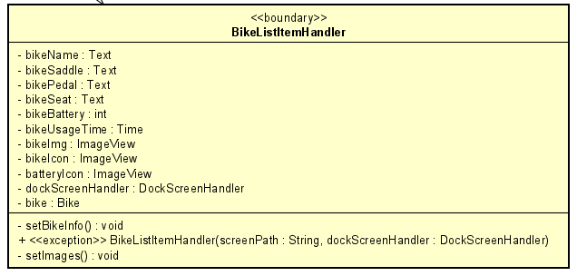

**Attribute**

|  |  |  |  |  |
| --- | --- | --- | --- | --- |
| # | Name | Data type | Default value | Description |
| 1 | bikeImg | ImageView | NULL | Bike image fxml |
| 2 | bikeIcon | imageView | NULL | Bike image fxml |
| 4 | bikeName | Text | NULL | Bike name |
| 5 | bikeSaddle | Text | NULL | Bike saddle |
| 6 | bikePedal | Text | NULL | Bike pedal |
| 7 | bikeSeat | Text | NULL | Bike seat |
| 8 | dockScreenHandler | DockScreenHandler | NULL | object |
| 9 | bike | Bike | NULL | object |
| 10 | bikeBattery | Int | NULL | Bike Battery |
| 11 | BikeUsageTime | Time | NULL | Bike Usage Time |

**Operation**

|  |  |  |  |
| --- | --- | --- | --- |
| # | Name | Return type | Description |
| 1 | setBikeInfo | void | Set bike info |
| 2 | setImages | void | Set bike image in list |

**Parameter:**

none

**Exception:**

IOException

**Method**

None

**State**

None

## Class “BarcodePopup”

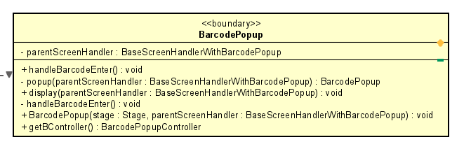

**Attribute**

|  |  |  |  |  |
| --- | --- | --- | --- | --- |
| # | Name | Data type | Default value | Description |
| 1 | parentScreenHandler | BaseScreenHandlerWithBarcodePopup | NULL | Parent screen |

**Operation**

|  |  |  |  |
| --- | --- | --- | --- |
| # | Name | Return type | Description |
| 1 | handleBarcodeEnter | void | Handle action “enter barcode” |
| 2 | popup | BaseScreenHandlerWithBarcodePopup | BarcodePopup |
| 3 | display | void | Display popup |
| 4 | handleBarcodeEnter | void | Button enter handler |
| 5 | barcodePopup | void | Popup barcode |
| 6 | getBController | BarcodePopupController | Get barcode |

**Parameter:**

* popup
  + parentScreenHandler
* display
  + parentScreenHandler
* barcodePopup
  + parentScreenHandler
  + stage

**Exception:**

None

**Method**

None

**State**

None

## Class “DockListItemHandler”

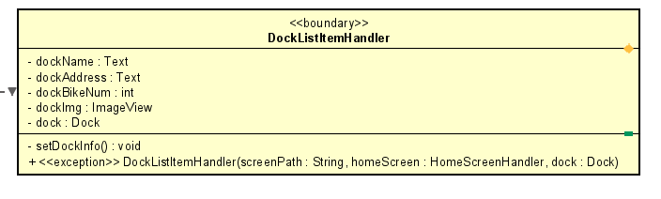

**Attribute**

|  |  |  |  |  |
| --- | --- | --- | --- | --- |
| # | Name | Data type | Default value | Description |
| 1 | dockName | Text | NULL | Dock name |
| 2 | dockAddress | Text | NULL | Dock address |
| 3 | dockBikeNum | int | NULL | Number of bikes in dock |
| 4 | dockImg | ImageView | NULL | Dock image |
| 5 | dock | Dock | NULL | dock |

**Operation**

|  |  |  |  |
| --- | --- | --- | --- |
| # | Name | Return type | Description |
| 1 | setDockInfo | void | Set dock info |

**Parameter:**

None

**Exception:**

IOException

**Method**

None

**State**

None

## Class “InvoiceScreenHandler”

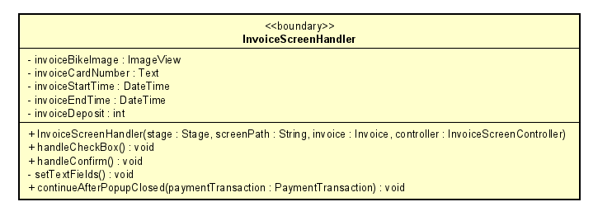

**Attribute**

|  |  |  |  |  |
| --- | --- | --- | --- | --- |
| # | Name | Data type | Default value | Description |
| 2 | invoiceBikeImage | ImageView | NULL | Bike image |
| 3 | invoiceCardNumber | Text | NULL | Invoice card number |
| 4 | invoiceStartTime | DateTime | NULL | Invoice start time |
| 5 | invoiceEndTime | DateTime | NULL | Invoice end time |
| 6 | invoiceDeposit | int | NULL | Invoice deposit |

**Operation**

|  |  |  |  |
| --- | --- | --- | --- |
| # | Name | Return type | Description |
| 1 | handleCheckBox | void | Handle check box |
| 2 | handleConfirmButton | void | Handle confirm button |
| 3 | setTextFields | void | Set text fields |
| 4 | continueAfterPopupClosed | void | Continue program after popup close |

**Parameter:**

* continueAfterPopupClosed
  + paymentTransaction

**Exception:**

None

**Method**

None

**State**

None

## Class “PaymentConfirmationScreenHandler”

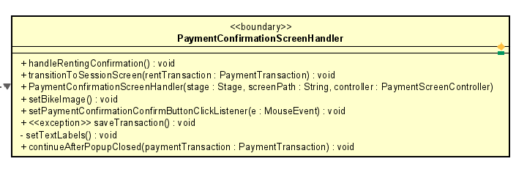

**Attribute**

|  |  |  |  |  |
| --- | --- | --- | --- | --- |
| # | Name | Data type | Default value | Description |

**Operation**

|  |  |  |  |
| --- | --- | --- | --- |
| # | Name | Return type | Description |
| 1 | handleRentingConfirmation | void | Handle confirmation action |
| 2 | transitionToSessionScreen | void | Transition to session screen |
| 3 | paymentConfirmationScreenHandler | void | Handle confirm payment |
| 4 | setBikeImage | void | Set bike image |
| 5 | setPaymentConfirmationConfirmButtonClickListener | void | Payment Confirmation Confirm Button Click Listener |
| 6 | saveTransaction | void | Save transaction |
| 7 | setTextLabels | void | Set text |
| 8 | continueAfterPopupClosed | void | Continue program after popup close |

**Parameter:**

* transitionToSessionScreen
  + rentTransaction
* paymentConfirmationScreenHandler
  + stage
  + screenPath
  + controller
* setPaymentConfirmationConfirmButtonClickListener
  + e
* continueAfterPopupClosed
  + paymentTransaction

**Exception:**

IOException

**Method**

None

**State**

None

## Class “PaymentScreenHandler”

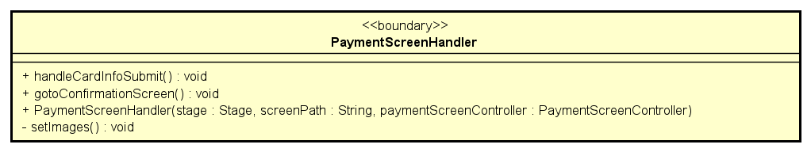

**Attribute**

|  |  |  |  |  |
| --- | --- | --- | --- | --- |
| # | Name | Data type | Default value | Description |

**Operation**

|  |  |  |  |
| --- | --- | --- | --- |
| # | Name | Return type | Description |
| 1 | handleCardInfoSubmit | void | Handle action submit card |
| 2 | gotoConfirmationScreen | void | Transition to confirmation screen |
| 3 | setImages | vodi | Set payment image |

**Parameter:**

None

**Exception:**

None

**Method**

None

**State**

None

## Class “ReturningDockListSelectionHandler”

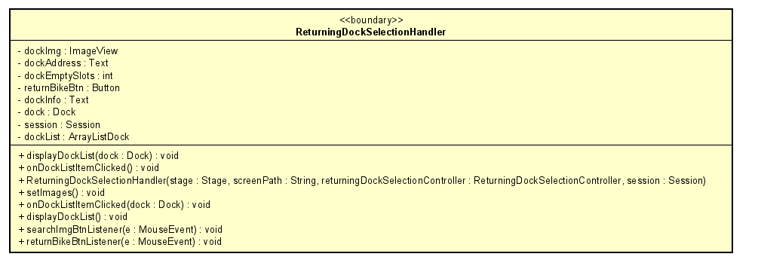

**Attribute**

|  |  |  |  |  |
| --- | --- | --- | --- | --- |
| # | Name | Data type | Default value | Description |
| 1 | returnBikeBtn | Button | NULL | Button to return bike |
| 2 | dockEmptySlots | int | NULL | Dock parking slot |
| 3 | dockImg | ImageView | NULL | Dock image fxml |
| 4 | dockInfo | Text | NULL | Dock information |
| 5 | dockAdress | Text | NULL | Dock address |
| 6 | dock | Dock | NULL | dock |
| 7 | session | Session | NULL | Session |
| 8 | dockList | ArrayListDock | NULL | Dock list |

**Operation**

|  |  |  |  |
| --- | --- | --- | --- |
| # | Name | Return type | Description |
| 1 | setDockInfo | void | Set dock info |
| 2 | onDockListItemClicked | void | Return dock clicked listener |
| 3 | setImages | void | Set return dock image |
| 4 | displayDockList | void | Display return dock list |
| 5 | searchImgBtnListener | void | Search image button listener |
| 6 | returnBikeBtnListener | void | Return bike button listener |

**Parameter:**

None

**Exception:**

None

**Method**

None

**State**

None

## Class “ReturningDockListItemHandler”

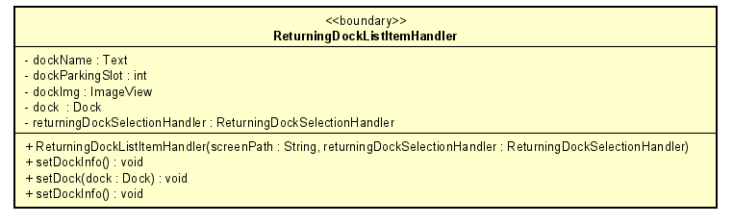

**Attribute**

|  |  |  |  |  |
| --- | --- | --- | --- | --- |
| # | Name | Data type | Default value | Description |
| 1 | dockName | Text | NULL | Dock name fxml |
| 2 | dockParkingSlot | int | NULL | Dock address fxml |
| 3 | dockImg | ImageView | NULL | Dock image fxml |
| 4 | dock | Dock | NULL | dock |
| 5 | returningDockSelectionHandler | ReturningDockSelectionHandler | NULL | Returning Dock Selection Handler |

**Operation**

|  |  |  |  |
| --- | --- | --- | --- |
| # | Name | Return type | Description |
| 1 | setDockInfo | void | Display dock information |
| 2 | setDock | void | Display dock |

**Parameter:**

* setDock
  + dock

**Exception:**

None

**Method**

None

**State**

None

## Class “SessionScreenHandler”

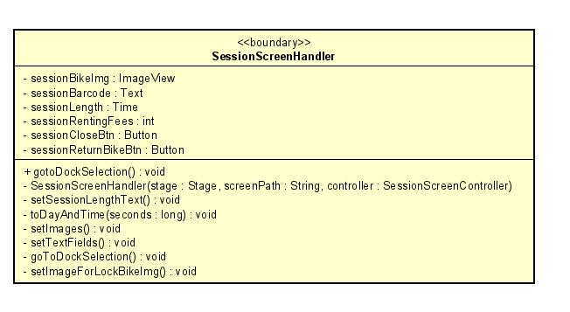

**Attribute**

|  |  |  |  |  |
| --- | --- | --- | --- | --- |
| # | Name | Data type | Default value | Description |
| 1 | sessionBikeImg | ImageView | NULL | Bike image fxml |
| 2 | sessionBarcode | Text | NULL | Session barcode |
| 3 | sessionLength | Time | NULL | Session length |
| 4 | sessionRentingFees | Int | NULL | Session renting fees |
| 5 | sessionCloseBtn | Button | NULL | Button |
| 6 | sessionReturnBikeBtn | Button | NULL | Button |

**Operation**

|  |  |  |  |
| --- | --- | --- | --- |
| # | Name | Return type | Description |
| 1 | gotoDockSeletion | void | Transition to dock selection |
| 2 | setSessionLengthText | void | Set session’s length text |
| 3 | toDayAndTime | void | Day and time conversion |
| 4 | setImages | void | Set image for session |
| 5 | setTextFields | void | Set text fields for session |
| 6 | goToDockSelection | void | Back to the dock selection |
| 7 | setImageForLockBikeImg | void | Set image for bike |

**Parameter:**

* ToDayAndTime
  + seconds

**Exception:**

None

**Method**

None

**State**

None

## Class “HomeScreenHandler”

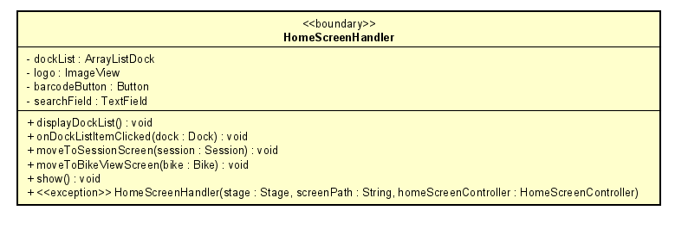

**Attribute**

|  |  |  |  |  |
| --- | --- | --- | --- | --- |
| # | Name | Data type | Default value | Description |
| 1 | vboxDockList | VBox | NULL | Vbox fxml |
| 2 | dockList | ArrayListDock | NULL | Dock list |
| 3 | logo | ImageView | NULL | Logo fxml |
| 4 | barcodeButton | Button | NULL | Barcode button fxml |
| 5 | searchField | TextField | NULL | Search field fxml |

**Operation**

|  |  |  |  |
| --- | --- | --- | --- |
| # | Name | Return type | Description |
| 1 | displayDockList | void | Display dock list |
| 2 | onDockListItemClicked | void | Dock list item clicked listener |
| 3 | moveToSessionScreen | void | Move to session screen |
| 4 | moveToBikeViewScreen | void | Move to bike view screen |
| 5 | show | void | Show screen |

**Parameter:**

* onDockListItemClicked
  + dock
* moveToSessionScreen
  + session
* moveToBikeViewScreen
  + bike

**Exception:**

IOException

**Method**

None

**State**

None

## Class “NavBarHandler”

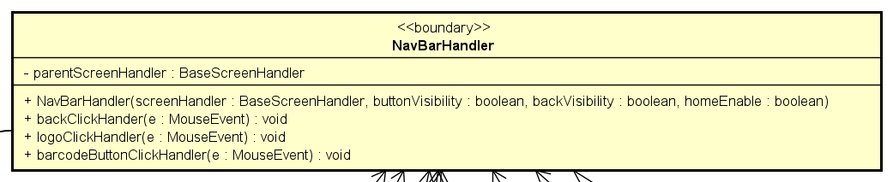

**Attribute**

|  |  |  |  |  |
| --- | --- | --- | --- | --- |
| # | Name | Data type | Default value | Description |
| 1 | parentScreenHandler | BaseScreenHandler | NULL | handler |

**Operation**

|  |  |  |  |
| --- | --- | --- | --- |
| # | Name | Return type | Description |
| 1 | backClickHandler | void | go to previous screen |
| 2 | logoClickHandler | void | go to home screen |
| 3 | barcodeButtonClickHandler | void | bring up barcode popup |

**Parameter:**

* backClickHandler
  + e – MouseEvent
* logoClickHandler
  + e - MouseEvent

**Exception:**

None

**Method**

None

**State**

None

## Class “BaseScreenHandlerWithTransactionPopup”

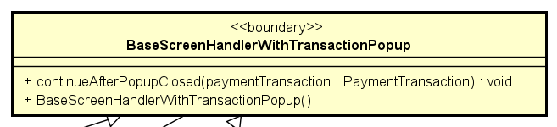

**Attribute**

None

**Operation**

|  |  |  |  |
| --- | --- | --- | --- |
| # | Name | Return type | Description |
| 1 | continueAfterPopupClosed | void | show then closed popup of payment result |

**Parameter:**

* continueAfterPopupClosed
  + paymentTransaction – transaction to be shown result

**Exception:**

None

**Method**

None

**State**

None

## Class “PaymentResultPopup”

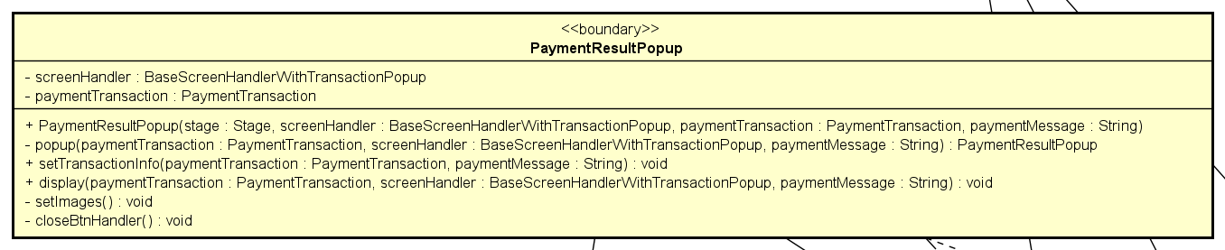

**Attribute**

|  |  |  |  |  |
| --- | --- | --- | --- | --- |
| # | Name | Data type | Default value | Description |
| 1 | screenHandler | BaseScreenHandlerWithTransactionPopup | new | handler |
| 2 | paymentTransaction | PaymentTransaction | NULL | transaction to be shown |

**Operation**

|  |  |  |  |
| --- | --- | --- | --- |
| # | Name | Return type | Description |
| 1 | setTransactionInfo | void | Display result |
| 2 | display | void | Render result |
| 3 | setImage | void | Set image for screen |
| 4 | closeBtnHandler | void | Close the popup and move to next screen |
| 5 | popup | PaymentResultPopup | Create then return popup |

**Parameter:**

* popup
  + screenHandler
  + paymentTransaction
  + paymentMessage

**Exception:**

None

**Method**

None

**State**

None

## Class “FXMLScreenHandler”

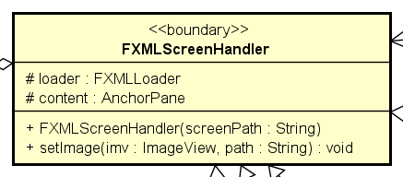

**Attribute**

|  |  |  |  |  |
| --- | --- | --- | --- | --- |
| # | Name | Data type | Default value | Description |
| 1 | loader | FXMLLoader | new |  |
| 2 | content | AnchorPane | NULL | main app anchor |

**Operation**

|  |  |  |  |
| --- | --- | --- | --- |
| # | Name | Return type | Description |
| 1 | setImage | void | set image for screen |

**Parameter:**

* setImage
  + imv – image holder to be set
  + path – path to image

**Exception:**

None

**Method**

None

**State**

None

## Class “BaseScreenHandler”

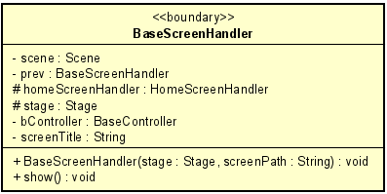

**Attribute**

|  |  |  |  |  |
| --- | --- | --- | --- | --- |
| # | Name | Data type | Default value | Description |
| 1 | scene | Scene | NULL | Scene to render |
| 2 | prev | BaseScreenHandler | NULL | Previous screen |
| 3 | homeScreenHandler | HomeScreenHandler | NULL | Home screen |
| 4 | stage | Stage | NULL | JavaFx stage |
| 5 | bController | BaseController | NULL | Controller for this screen |
| 6 | screenTitle | String | NULL | Title of this screen |

**Operation**

|  |  |  |  |
| --- | --- | --- | --- |
| # | Name | Return type | Description |
| 1 | show | void | Render the screen |

**Parameter:**

**Exception:**

None

**Method**

None

**State**

None